LAB EXPERIMENT RECORD
Set 1: Monthly Sales Data

Department | AI&DS
Course Code / Course Name | DSA0602 / Data Handling and Visualization
Experiment | Data Visualization using R
Name | DEVAMADA HEMASREE
Register Number | 192524114
Date | 29 September 2026
Day | Tuesday

Set 3: Employee Performance Evaluation
Dataset: Employee Performance
 |  |  | Employee ID Department Years of Service Performance Score
1 | Sales | 5 | 85
2 | HR | 3 | 92
3 | Marketing | 7 | 78
4 | Sales | 4 | 90
5 | HR | 2 | 76

PROGRAM 1: Line Chart (Performance Trend)
Aim: To show the performance trend of employees using a line chart.
graphics.off()
emp_id <- c(1, 2, 3, 4, 5)
score <- c(85, 92, 78, 90, 76)

plot(emp_id, score, type = "o", col = "blue", pch = 19,
xlab = "Employee ID", ylab = "Performance Score",
main = "Employee Performance Trend", ylim = c(70, 100))

abline(h = mean(score), col = "red", lty = 2)

legend("topright",
legend = c("Performance Score", "Average Score"),
col = c("blue", "red"), lty = c(1, 2), pch = c(19, NA))
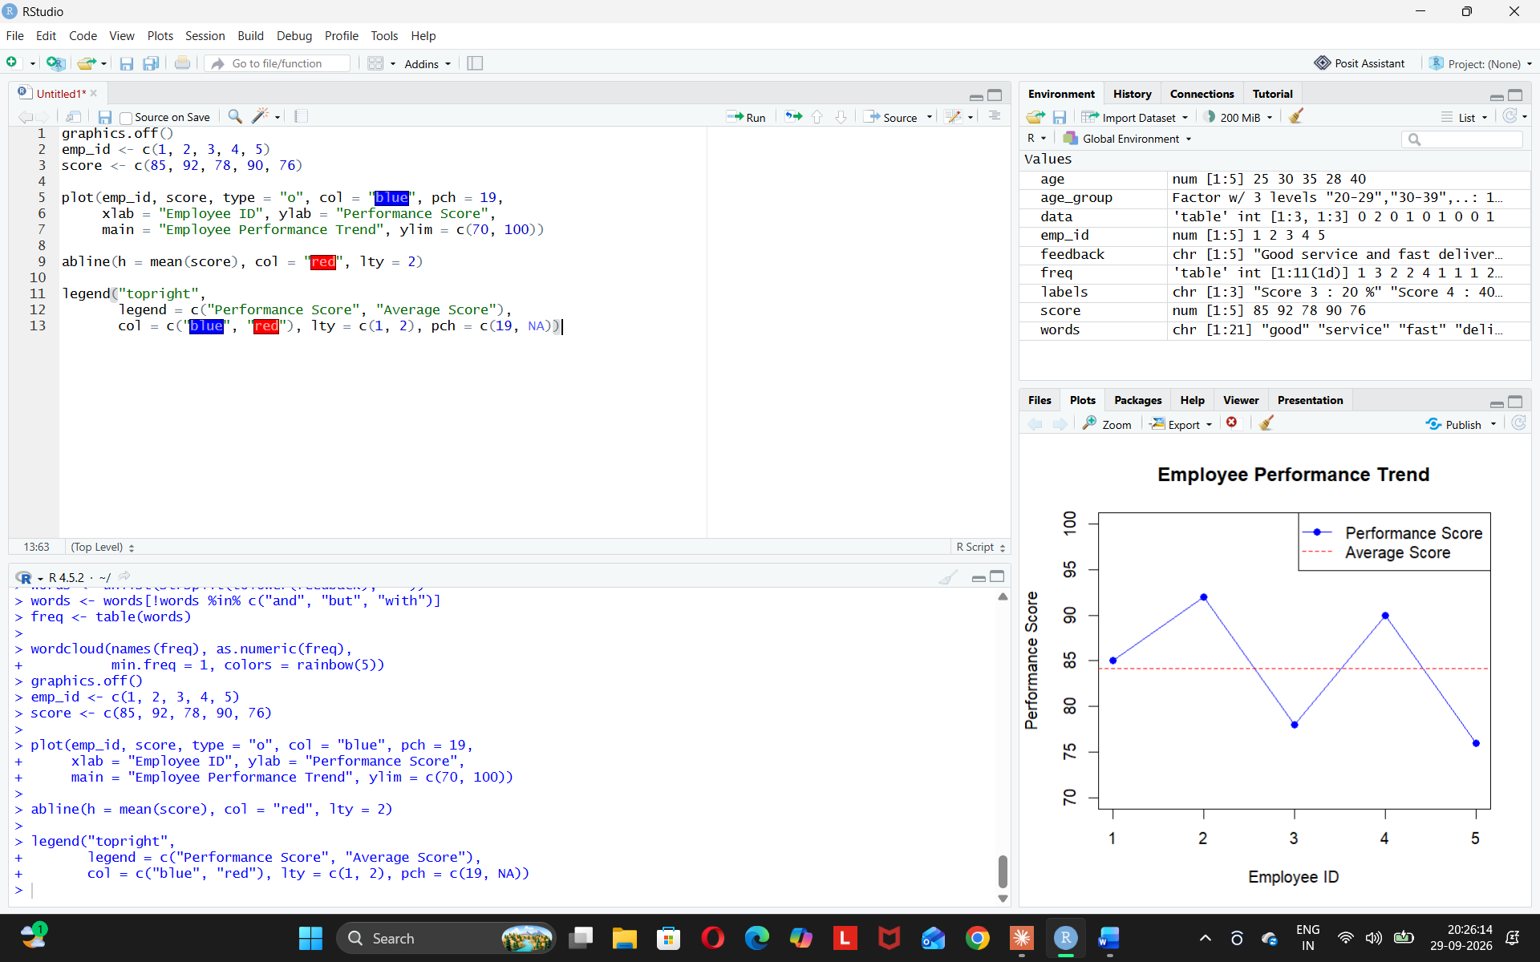
Observation: Employee 2 has the highest score (92), Employee 5 has the lowest (76).
PROGRAM 2: Bar Chart (Employees by Department)
Aim: To show the distribution of employees across departments.
graphics.off()
dept <- c("Sales", "HR", "Marketing", "Sales", "HR")
count <- table(dept)

barplot(count,
xlab = "Department", ylab = "Number of Employees",
main = "Employees by Department",
col = c("lightgreen", "orange", "skyblue"))
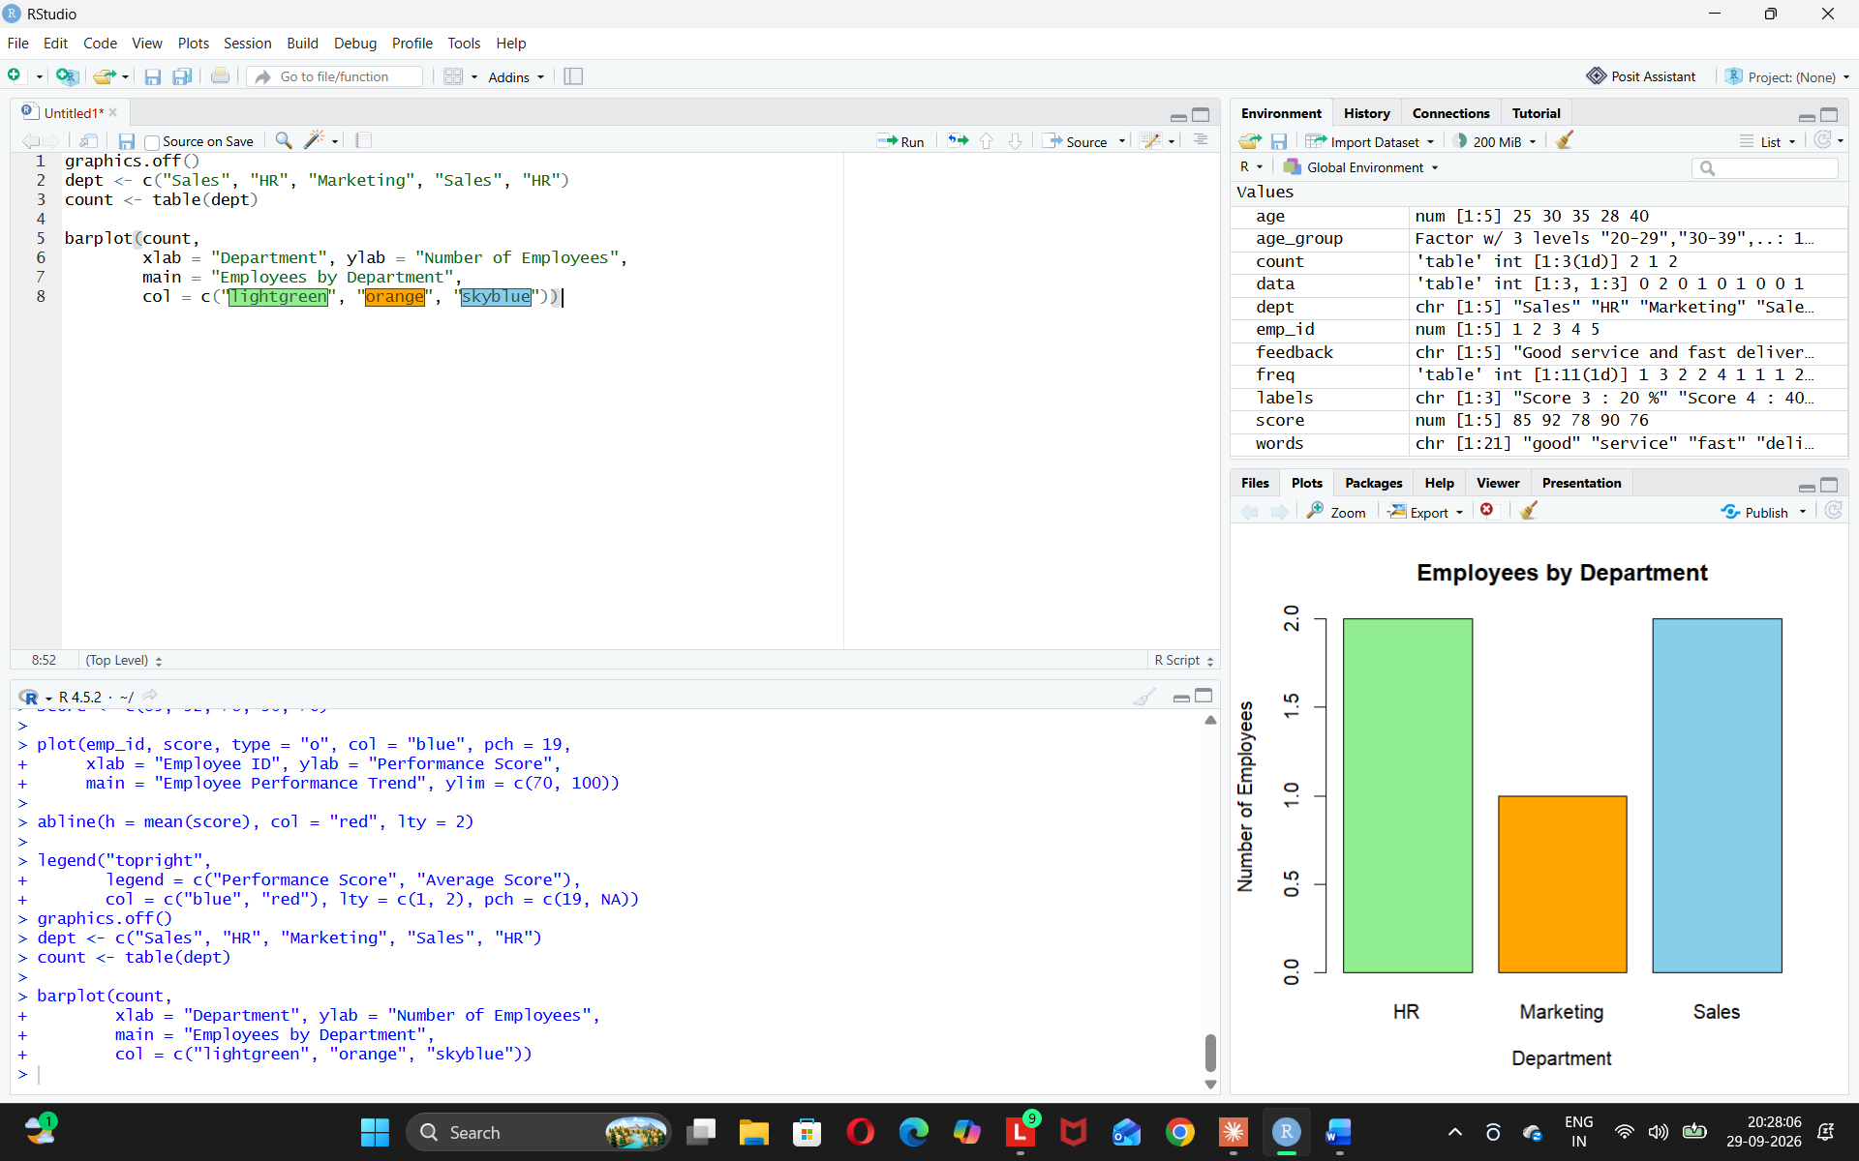
Observation: HR and Sales have the most employees. Marketing has the fewest.
PROGRAM 3: Scatter Plot (Years of Service vs Performance)
Aim: To study the relationship between years of service and performance score.
graphics.off()
years <- c(5, 3, 7, 4, 2)
score <- c(85, 92, 78, 90, 76)

plot(years, score,
xlab = "Years of Service", ylab = "Performance Score",
main = "Years of Service vs Performance",
pch = 19, col = "red")
abline(lm(score ~ years), col = "blue")

cor(years, score)
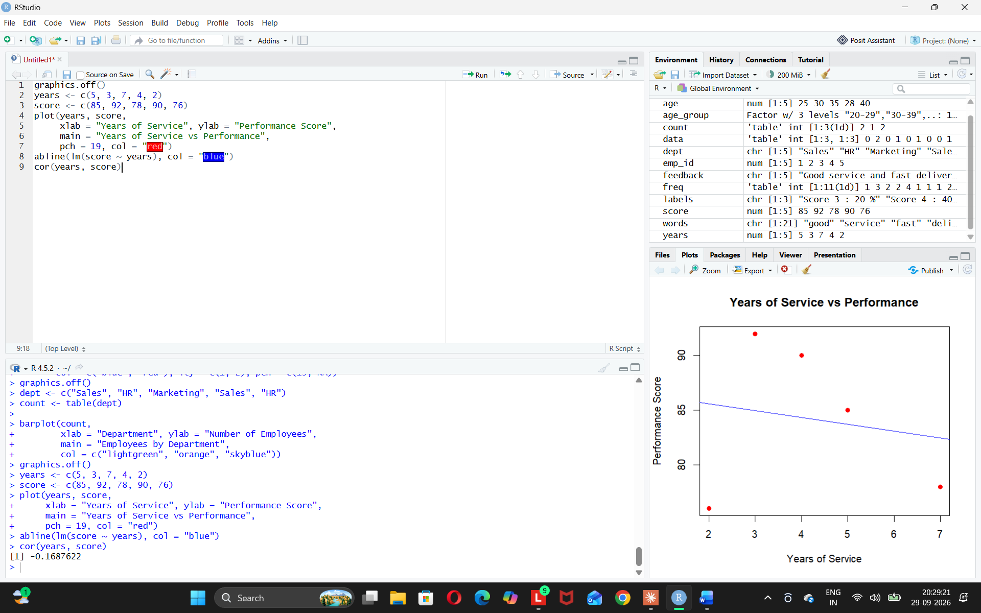
Insights:
- Correlation is about -0.17, so it is very weak.
- Years of service does not clearly affect performance.
- New employees can also perform well (Employee 2: 3 years, score 92).
- More data is needed for a strong conclusion.

PROGRAM 4: Tableau Dashboard
Aim: To build an interactive dashboard with the line chart and bar chart in Tableau.

